Name: Kainaat Rafiq Hussain Makhani
Registration Number: 2012296
Semester and Section: 7A
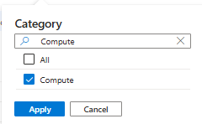
Lab 10

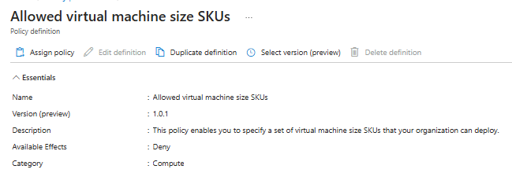

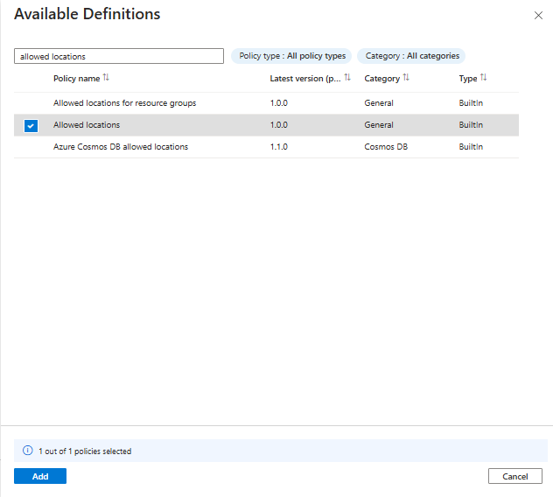

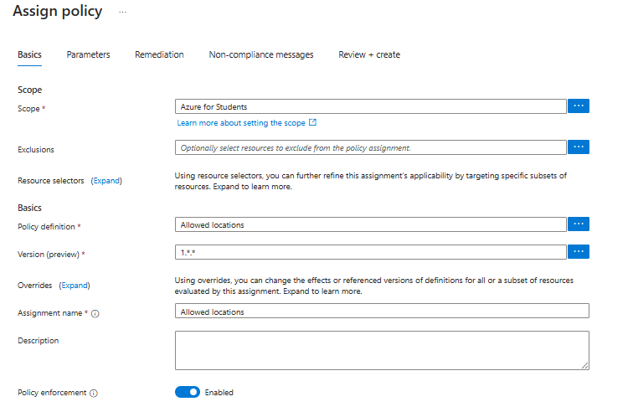

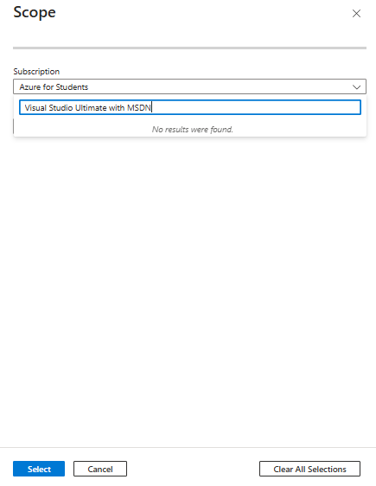

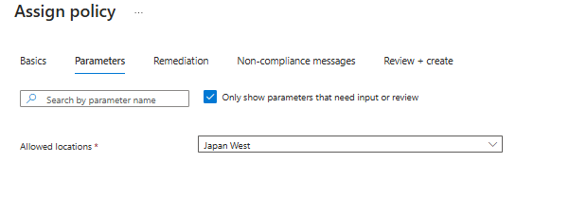

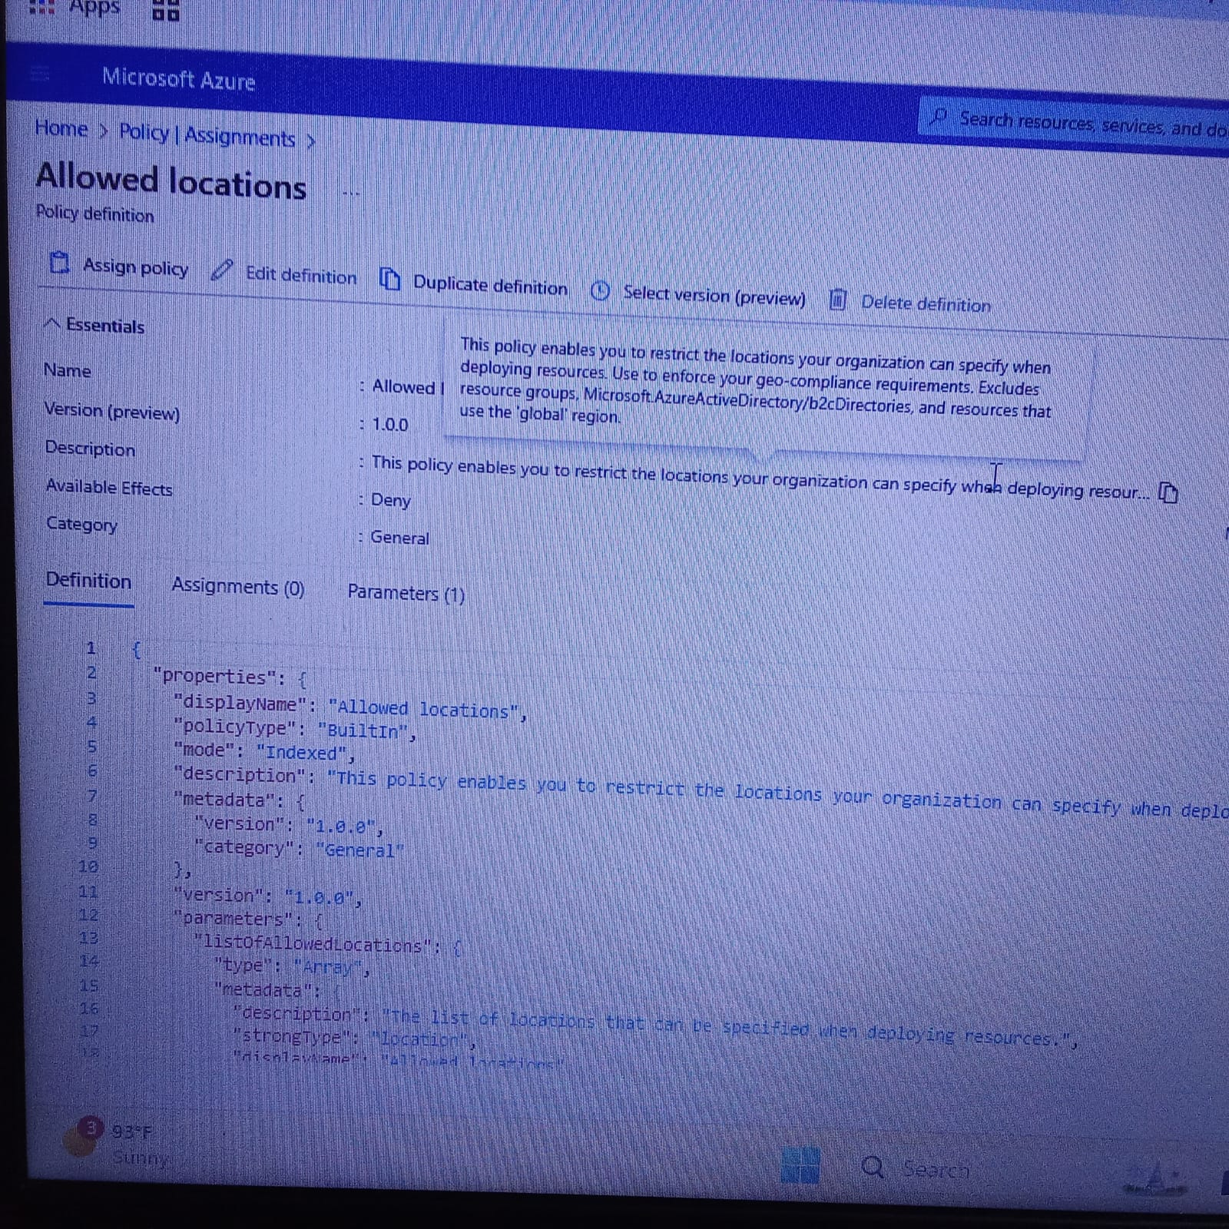

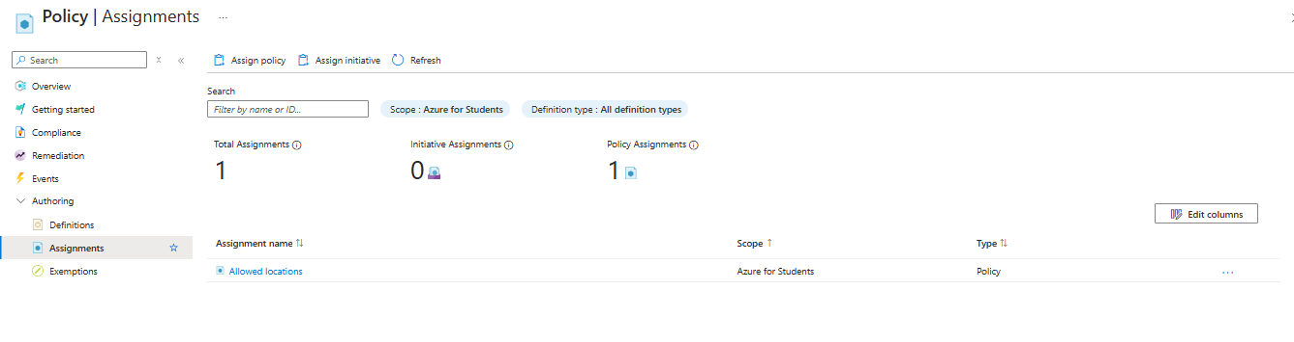

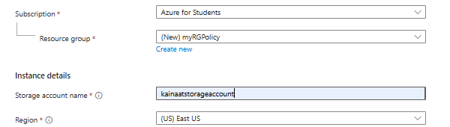

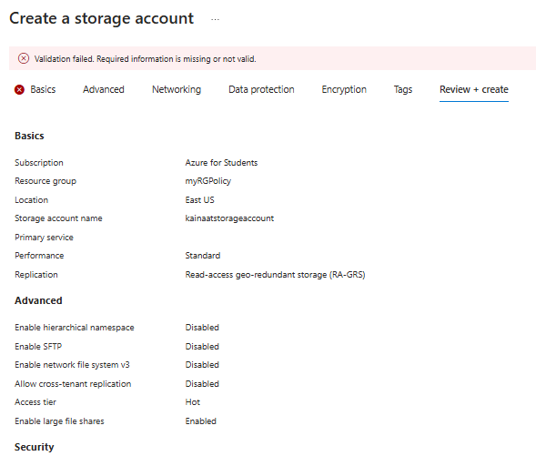

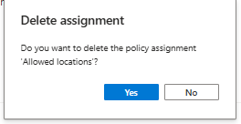

Description:
In this task, you will create an Azure Policy to restrict the deployment of Azure resources to a specific location, such as Japan West, within a subscription. The policy will ensure that resources can only be deployed in the specified location. If a resource is attempted to be deployed outside of the allowed location, the deployment will fail with an error message. After testing the policy by attempting to create a resource in an unauthorized location, you will delete the policy assignment to remove the restriction.

